Visual Studio Code – Integrated Development Environment (IDE)
How to install Visual Studio Code and run the C program?
- Go to the weblink - https://code.visualstudio.com/
- Click on the ‘Download the window (stable build)’ (recommended)
- Double click on the .exe file that you downloaded
- Routine process like next.. next..
- Enable the tick for ‘don’t create a start menu folder’ option while in step 4 process
- Select additional task one page will appear in Step 4, select all options
- Once all the steps over it will start install
- Click on the finish button as last step of VSC installation
Now we installed IDE for writing code. But if I need to C code then I need a compiler, so follow these steps,
- Search for MINGW compiler in google
- You will find sourceforge.net as one of the link, click it and download it
- Double click on the .exe file that you downloaded
- Click on install button and then in next page continue, it takes some time to install.
- Then continue, it will open MinGW installation manager, select all, then click on installation and apply changes and then click on apply, once finished close it
- Check with command prompt for its availability, g++
- Then try and see, where you installed in C drive, then see bin, then from that type cmd, it will open from MinGW/bin then type g++ --version, you will get it.
- Now to link this compiler to our environment, copy the path of MinGW/bin path and explore ‘environment’ in windows, then you find,
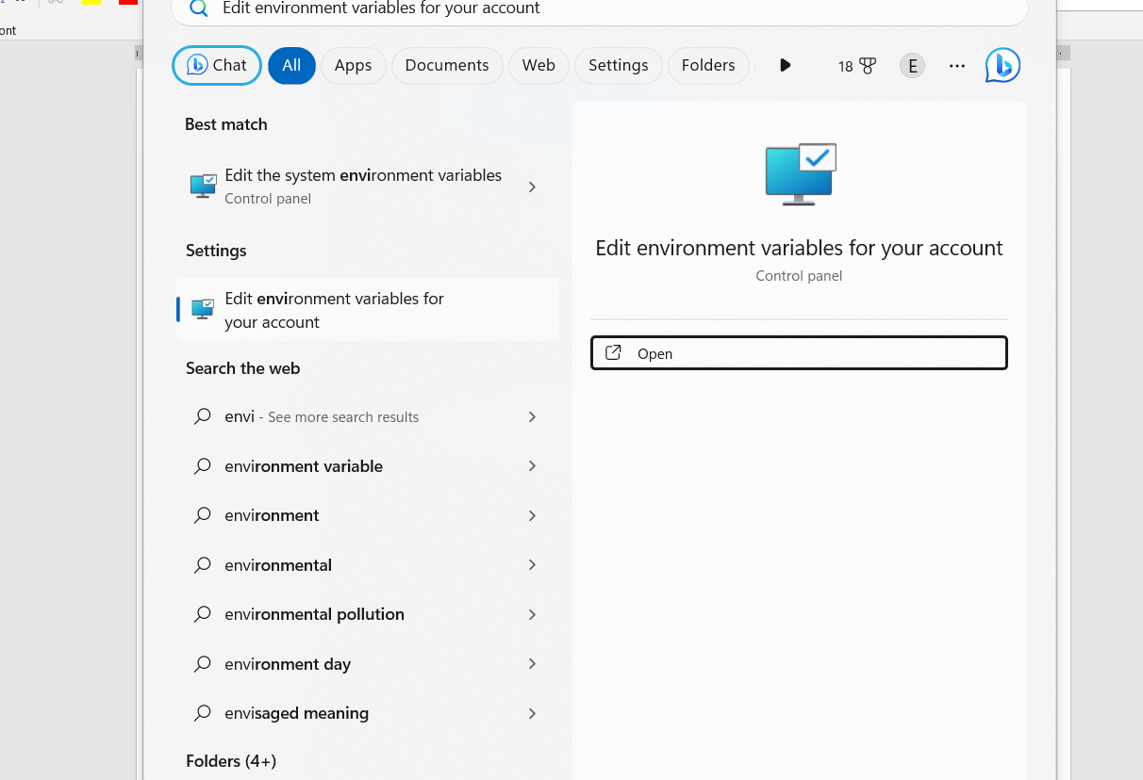
- Click on environmental variables button
- Under system variable option, click on path option from user variable (bottom option), new-> then copy the path..ok ok..
- Click on VSC, open a folder. Then open file .c.
- Click on extension in VSC, install C/C++ and code runner extensions
- Go to settings- then settings – search terminal then go to last . we have option called code runner: Run in terminal – check that if not enabled

